Dear ____________,

My name is _______, and I am a third-grade teacher in ______. We are involved in the Wyoming Stewardship Project with Wyoming Agriculture in the Classroom. We have been studying Wyoming agriculture in our classroom and focusing specifically on livestock. We studied the challenges that our stewards face in raising livestock. My class has written you letters thanking you for your hard work and stewardship within your field. They also will be pointing out a few of the things that they learned through this unit. We want you to know that we value your service and that you are an integral part of Wyoming culture.

Thank you,

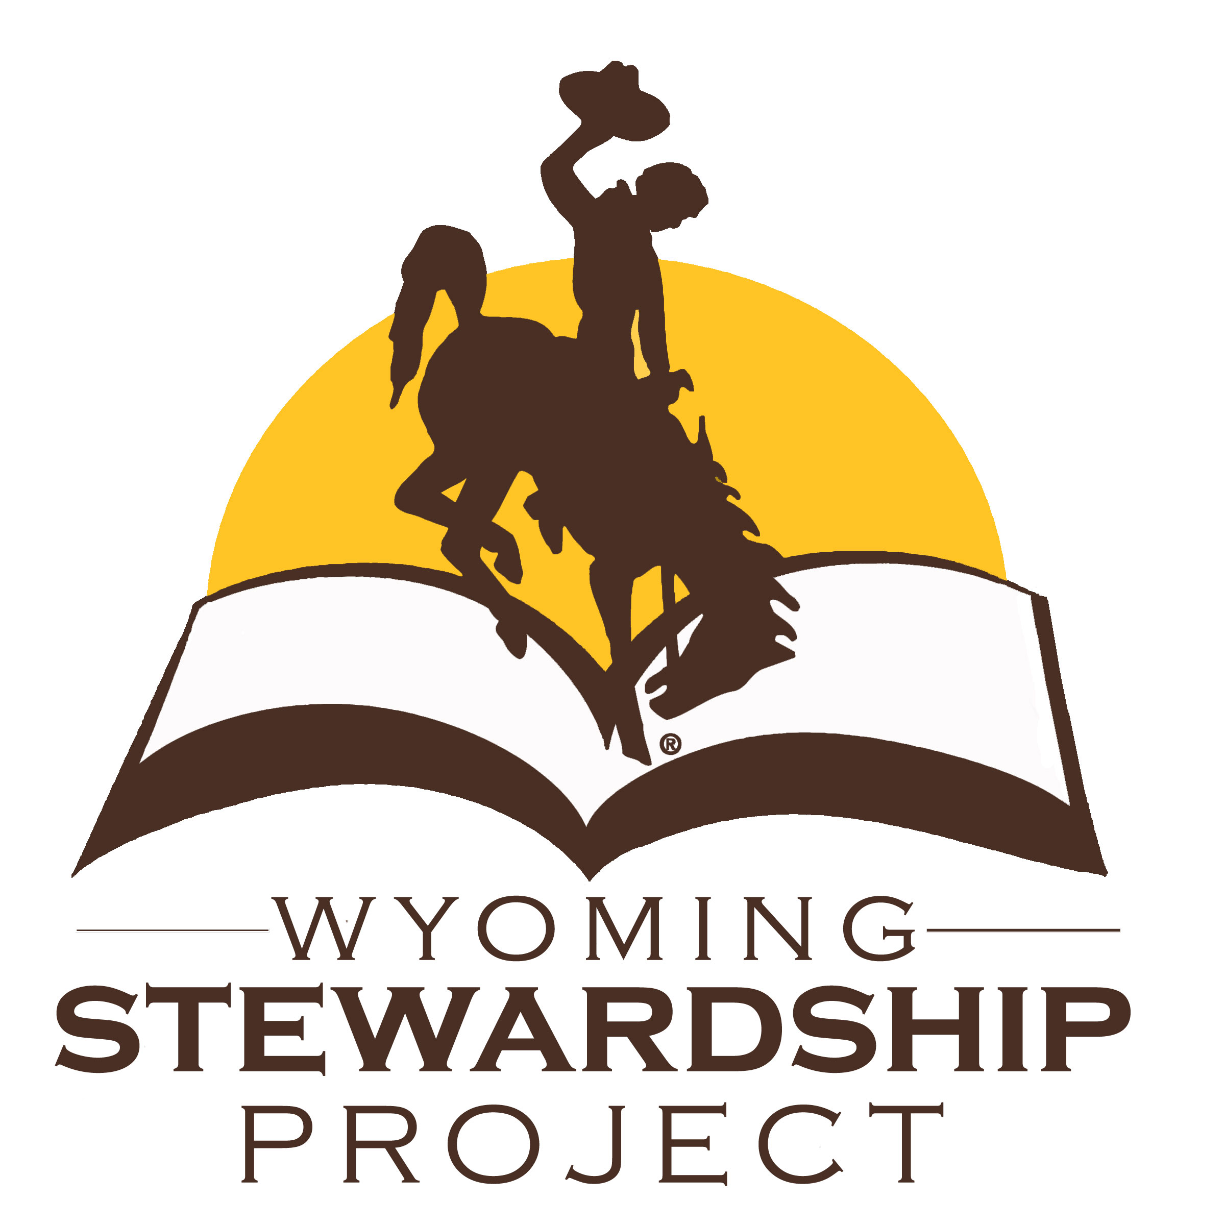© 2017 Wyoming Agriculture in the Classroom Materials